**Project Design Phase-II**

**Data Flow Diagram User Stories**

|  |  |
| --- | --- |
| Date | 15 October 2022 |
| Team ID | PNT2022TMID38493 |
| Project Name | Signs with Smart Connectivity for Better Road Safety |
| Maximum Marks | 4 Marks |

**Data Flow Diagram:**

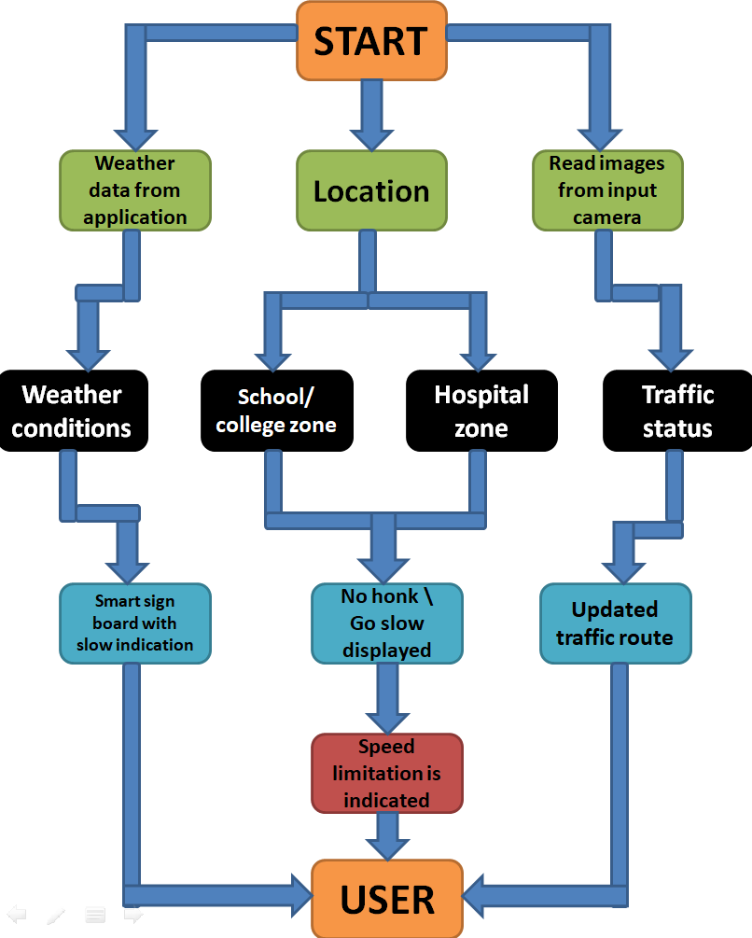

**User Stories**

|  |  |  |  |  |  |  |
| --- | --- | --- | --- | --- | --- | --- |
| **User Type** | **Functional Requirement**  **(Epic)** | **User Story Number** | **User Story / Task** | **Acceptance criteria** | **Priority** | **Release** |
| Customer (Mobile user) | Registration | USN-1 | I can get my speed limitation using weather application. | I can receive speed limitations | High | Sprint-1 |
|  |  | USN-2 | As a user, I can register for the application byentering my email, password, and confirmingmy password. As a user, | I can access my account /dashboard | Medium | Sprint-2 |
|  |  | USN-3 | As a user, I can increase or decrease my speed according to the weather change | I can increase or decrease my speed | High | Sprint-1 |
|  |  | USN-4 | As a user, I can I get my traffic diversion signs depending on the traffic and the fatal situations. | I can access my traffic status ahead in my travel | Medium | Sprint-1 |
|  | Login | USN-5 | As a user, I can log into the open weather map byentering email & password | I can access the application through my  Gmail login | High | Sprint-2 |
|  | Interface | USN-6 | As a user the interface should be simple and easily accessible | I can access the interface easily | High | Sprint-1 |
| Customer (Web user) | Data generation | USN-7 | As a user I use open weather application to access the data regarding the weather changes. | I can access the data regarding the weather through the application | High | Sprint-1 |
| Administrator (Officials) | Problem solving/ Fault clearance | USN-8 | As an official who is in charge for the proper functioning of the sign boards have to maintain it through periodic monitoring. | Officials can monitor the sign boards for proper functioning. | Medium | Sprint-2 |